The Code of Hammurabi
Analyzing Primary Sources

Around 1770 B.C., the sixth king of the city-state of Babylon, whose name was Hammurabi, wrote a code of law to govern his people. This is one of the earliest law codes ever recorded. Hammurabi had his laws carved into large “stele” which are tall stone slabs. There are 282 laws divided into different categories such as laws dealing with business contracts, laws to regulate family relationships and laws to keep the peace and mete out (or distribute) punishment for criminals. Many of the punishments are harsh, including death or disfigurement. Because of this, the code is often referred to as “an eye for an eye, a tooth for a tooth.”
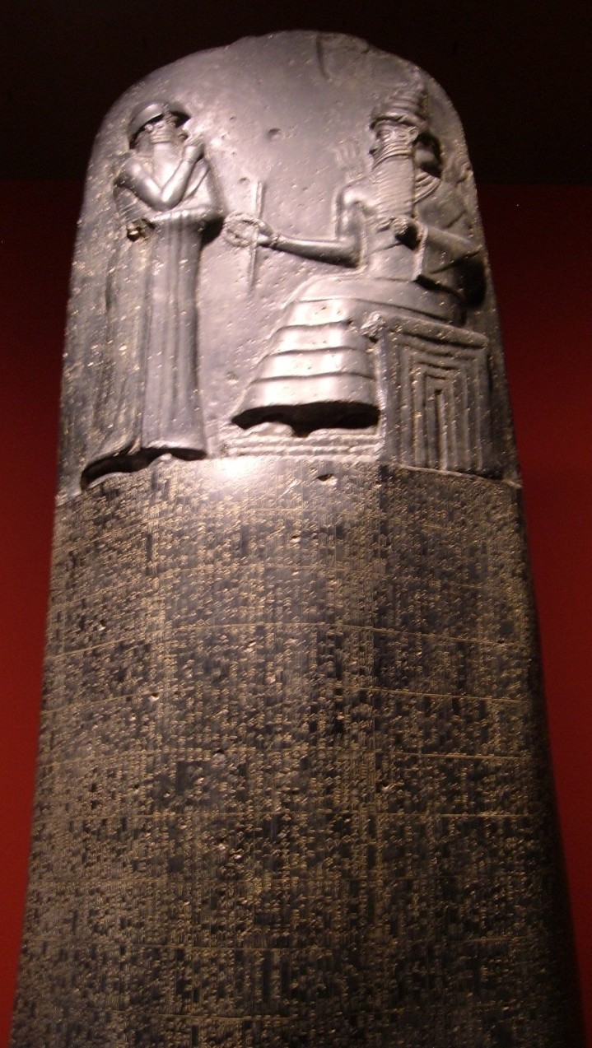
The preface to the law code extols the virtues of Hammurabi:

“Anu and Bel (gods) called me, Hammurabi, the exalted prince, the worshiper of the gods, to cause justice to prevail in the land, to destroy the wicked and the evil, to prevent the strong from oppressing the weak, to go forth like the Sun over the Black Head Race, to enlighten the land and to further the welfare of the people. Hammurabi, the governor named by Bel, am I, who brought about plenty and abundance; who made everything …complete; the exalted supporter of E-‐kur; the wise king… who stormed the four quarters of the world; who made the fame of Babylon great… When Marduk sent me to rule the people and to bring help to the country, I established law and justice in the land and promoted the welfare of the people.”

The preface above is a primary source because it was written at the time Hammurabi lived. A primary source is an eyewitness account, unlike a secondary source that might be a later re-telling of an event by someone who was not there to witness it. On the next page are some of the laws from the Code of Hammurabi.
*Vocabulary Activity: Make a guess about what the phrase, “extols the virtues” might mean. Write your answer here:

Name: Date:

From the Code of Hammurabi

#1. If a man bring an accusation against a man, and charge him with a crime, but cannot prove it, he, the accuser, shall be put to death.

#2. If a man charge a man with sorcery, and cannot prove it, he who is charged with sorcery shall go to the river, into the river he shall throw himself and if the river overcome him, his accuser shall take to himself his house. If the river show that man to be innocent and he come forth unharmed, he who charged him with sorcery shall be put to death. He who threw himself into the river shall take to himself the house of his accuser.

#25. If a fire break out in a man's house and a man who goes to extinguish it casts his eye on the furniture of the owner of the house, and take the furniture of the owner of the house, that man shall be thrown into that fire.

#26. If either an officer or a constable, who is ordered to go on an errand of the king, do not go but hire a substitute and dispatch him in his stead, that officer or constable shall be put to death; his hired substitute shall take to himself his (the officer's) house.

#127. If a man accuse a priestess or the wife of another and cannot justify it, they shall drag that man before the judges and they shall brand his forehead.

#195. If a son strike his father, they shall cut off his fingers.

#196. If a man destroy the eye of another man, they shall destroy his eye.

#197. If one break a man’s bone, they shall break his bone.

#200. If a man knock out a tooth of a man of his own rank, they shall knock out his tooth.

# 229. If a builder build a house for a man and do not make its construction firm, and the house which he has built collapse and cause the death of the owner of the house, that builder shall be put to death.
Inference Activity: Law #2, proving innocence by throwing oneself into a river, is difficult to understand. Read the law carefully. What do you think it means to say “if the river show that man to be innocent?” How might a river show a man to be innocent? Write you answer below.

Name: Date:

Analyzing a Primary Source
Evidence from Text to Support a Thesis

Hammurabi’s Code is often referred to as “an eye for an eye, a tooth for a tooth.” Give some examples from the laws that support this statement.

Re-read the preface to Hammurabi’s Code. What evidence is in the preface that tells you what Hammurabi’s purpose was in writing this code? What was he trying to accomplish with his laws?

These laws were harsh and covered many aspects of the life of Hammurabi’s people.
What does Hammurabi say in the preface that would make people accept his rule? How does he prove that he is the rightful king and his laws should be obeyed?

Name: Date:

Connecting
Compare and Contrast

Choose three laws from Hammurabi’s Code. Compare those laws to our own society’s laws. Do you think our laws, or Hammurabi’s laws would be more effective and why?

Hammurabi’s Law What was the offense?  What was the punishment? | Modern Law  What is a similar offense? What might be the punishment? | Your thoughts about which law system is better.
Example:  #229 If a builder builds a house and it is unsafe, the builder will be put to death. | Example:  Someone builds or sells a product that is unsafe or unusable. The person would probably be sued, brought to court, and have to pay damages. They might go to jail if they were negligent. | Example:  Sometimes things happen by accident and not because someone was careless. It is better to pay a fine or go to jail so you don’t kill people for a crime that was not meant to hurt anyone.

Name: ____________________________ Date: _____________

Supporting an Argument

Use what you have learned about life in Mesopotamia and the Code of Hammurabi to answer the following question. Be sure to use a topic sentence (thesis), support for your choice (evidence) from the readings, and a concluding sentence summing up your main point.

Question: Would you prefer to live in the city of Babylon, under the rule of Hammurabi,
or to live in our present day and time?

