HAMMURABI FACT SHEET Reading

The land of Sumer became known as Babylonia. One of the greatest kings of Babylonia was King Hammurabi. He became king in 1792 B.C. and ruled for 43 years. Hammurabi was known for his wisdom and justice. He developed one of the first written codes of law in the world. King Hammurabi studied all the laws of Babylonia and put them together to make a new code of laws. Hammurabi’s code had 282 laws. These laws provided rules for settling problems what arose in the everyday lives of the Babylonians. These laws were designed to prevent the strong from oppressing the weak. There were laws for such things as family, trade, wages, loans, businesses, and military service. The code of laws replaced personal revenge for legal penalties in dealing with crimes. In many cases the required punishments were quite severe, such as cutting off a hand or putting out an eye. King Hammurabi had his code of laws engraved on a large slab of stone so that people could see and read the laws. This stone is called the stele of Hammurabi and is 7 feet tall. Long after the end of the Babylonian empire, Hammurabi’s code continued to influence the development of other legal systems in the Middle East. Today, the stele of Hammurabi is located in the Louvre Museum in Paris, France.

- What is a code of laws?

- What punishments were possible under the code of Hammurabi?

- How did Hammurabi reform (change) Babylonian society?

Link to Hammurabi’s code: http://avalon.law.yale.edu/ancient/hamframe.asp
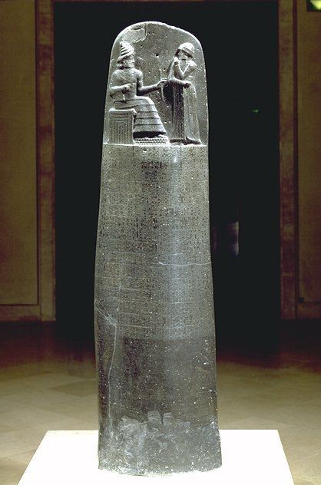
Stele of Hammurabi

