THE GEOGRAPHY OF ANCIENT EGYPT
CH 4: Section 1: pp. 86 – 89 in World History textbook
THE BIG IDEA:

THE MAIN IDEAS:

3.

VOCABULARY:
- cataracts [p. 87]:
- delta [p. 87]:
- Menes [p. 89]:
- pharaoh [p. 89]:
- dynasty [p. 89]:

The Gift of the Nile

Location and Physical Features

Regions:

Physical Features:

- The Floods of the Nile

- Silt:

Civilization Develops Along the Nile

Hunter-gatherers:

Mesopotamia:

Diet:

Natural Barriers:

Kings Unify Egypt

3100 BCE:

Invasion of Menes:

Memphis:

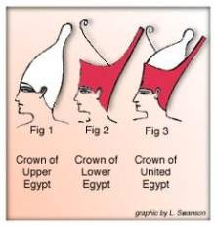

First Dynasty:

