Name: _____________________________________ Date: ______ Period: ____

Catal Huyuk is one of the oldest towns ever found by archaeologists, dating back more than 9,000 years. While only having been excavated sporadically over the past 100 years, the site has given historians and archaeologists great insights into how humanity first decided to settle into towns.

Catal Huyuk
Catal Huyuk (pronounced cha-tel hoo-yek, or Çatalhöyük in Turkish) is an archaeological site in what is now south-central Turkey. Along with Jericho, it's considered one of the oldest cities in the world, dating from almost 7500 BC. The site, which means 'fork mound' in Turkish, sits astride what was once a river valley. Inhabited for almost 2000 years by thousands of people, the site demonstrates how humanity changed during the transition from the Neolithic period (the New Stone Age) to the Chalcolithic period (the Copper age), as well as from hunting and gathering towards herding and farming, all the while providing insights for how the earliest citizens provided for the town's defense and religion.

The Structure
Perhaps what is most unique for modern observers of the city is that there are no streets. Indeed, it looks like Catal Huyuk is one gigantic building comprised of several smaller cells, almost like an anthill or honeycomb. Instead of independent structures, the citizens of Catal Huyuk chose to build their houses abutting each other on all sides, with entrances built under the ledge of each house. These entrances in turn served as ventilation for the cooking that happened below, as well as provided a vent for warm air to rise up while the cooler earth provided some level of natural air conditioning.
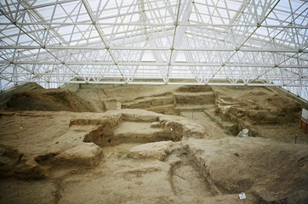
Catal Huyuk under excavation

The exterior walls of the settlement were reinforced with wooden supports in addition to the mud brick of the standard walls, as were the ceilings of each dwelling. The roofs of the town acted as streets. Inside the homes, one is immediately shocked to find artwork detailing the daily lives, as well as the ceremonial lives, of the citizens of Catal Huyuk. Some of the more famous wall paintings include hunting scenes, as well as landscapes from the surrounding countryside. Additionally, in sharp contrasts to other sites, the dwellings are remarkably clear of debris.
Daily Life

Cleanliness does not indicate that citizens of Catal Huyuk had little to do, however. As the town made the transition from a hunter-gatherer site to a true city, various implements were needed in order to complete the tasks associated with both farming and herding. Archaeologists have found numerous articles to this end, especially stone and obsidian tools.

Further, granaries for storing food have been found, complete with the remains from prehistoric wheat, peas, and nuts. Combined with pits full of bones from sheep, it is apparent that the citizens of Catal Huyuk had a balanced diet. This is further collaborated by the importance of hunting in paintings, especially for ceremonial purposes.

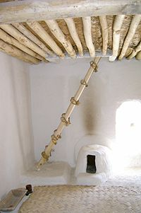
Response Questions:

- Define Catal Huyuk:

- What can historians and archaeologists learn from studying this site?

- Describe the structure of Catal Huyuk:

- What does the structural design infer?

- Describe a day in the life of a Catal Huyuk resident:

Restored interior of a house at Catal Huyuk

