Name: __________________________________ Date: ___/___/______ Period: _____

NOTES
Back to School (2003) presented by Wide Angle, PBS
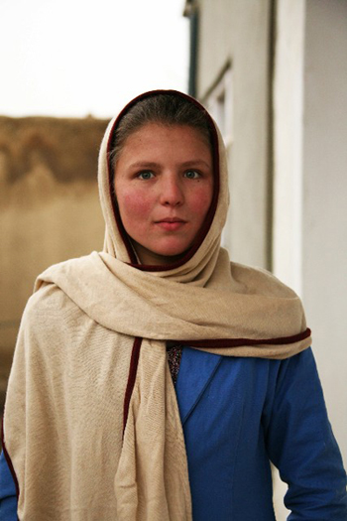  Shugufa  Afghanistan | Important information about Afghanistan: ___________________________________________________  ___________________________________________________  ___________________________________________________  ___________________________________________________  ___________________________________________________  ___________________________________________________  ___________________________________________________  ___________________________________________________  ___________________________________________________  ___________________________________________________
Factor |  | Negative Impact | Positive Impact

Additional information about Shugufa: ______________________________________________________________________________
__________________________________________________________________________________________________________________________________________________________________________________________________________________________________________
______________________________________________________________________________
______________________________________________________________________________
______________________________________________________________________________

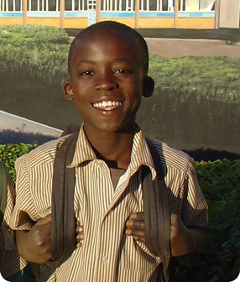  Joab  Kenya | Important information about Kenya:  _________________________________________________  _________________________________________________  _________________________________________________  _________________________________________________  _________________________________________________  _________________________________________________  _________________________________________________  _________________________________________________  _________________________________________________
Factor |  | Negative Impact | Positive Impact

Additional information about Joab: ______________________________________________________________________________
______________________________________________________________________________________________________________________________________________________________________________________________________________________________________________________________________________________________________________________________________________________________________________________________________
______________________________________________________________________________
______________________________________________________________________________

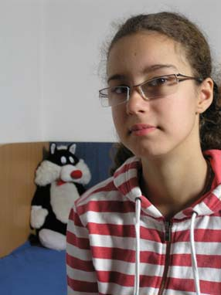  Raluca  Romania |  | Important information about Romania:  __________________________________________________  __________________________________________________  __________________________________________________  __________________________________________________  __________________________________________________  __________________________________________________  __________________________________________________  __________________________________________________  __________________________________________________  __________________________________________________
Factor | Negative Impact |  | Positive Impact

Additional information about Raluca: ______________________________________________________________________________
______________________________________________________________________________________________________________________________________________________________________________________________________________________________________________________________________________________________________________________________________________________________________________________________________
______________________________________________________________________________
______________________________________________________________________________

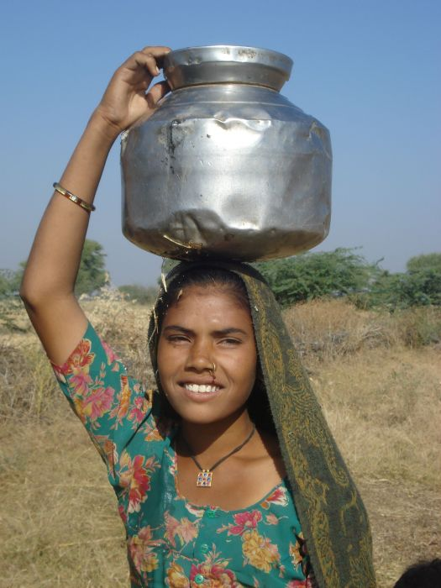  Neeraj  India | Important information about India:  ___________________________________________________  ___________________________________________________  ___________________________________________________  ___________________________________________________  ___________________________________________________  ___________________________________________________  ___________________________________________________  ___________________________________________________  ___________________________________________________  ___________________________________________________  ___________________________________________________
Factor |  | Negative Impact | Positive Impact

Additional information about Neeraj: ______________________________________________________________________________
______________________________________________________________________________________________________________________________________________________________________________________________________________________________________________________________________________________________________________________________________________________________________________________________________
______________________________________________________________________________

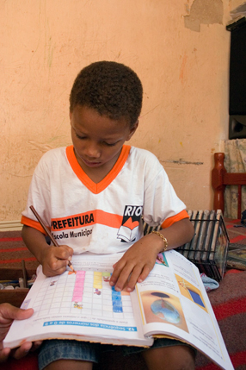  Jefferson  Brazil | Important information about Brazil:  ___________________________________________________  ___________________________________________________  ___________________________________________________  ___________________________________________________  ___________________________________________________  ___________________________________________________  ___________________________________________________  ___________________________________________________  ___________________________________________________  ___________________________________________________
Factor |  | Negative Impact | Positive Impact

Additional information about Jefferson: ______________________________________________________________________________
____________________________________________________________________________________________________________________________________________________________________________________________________________________________________________________________________________________________________________________________________________________________________________________________________________________________________________________________________________________
______________________________________________________________________________

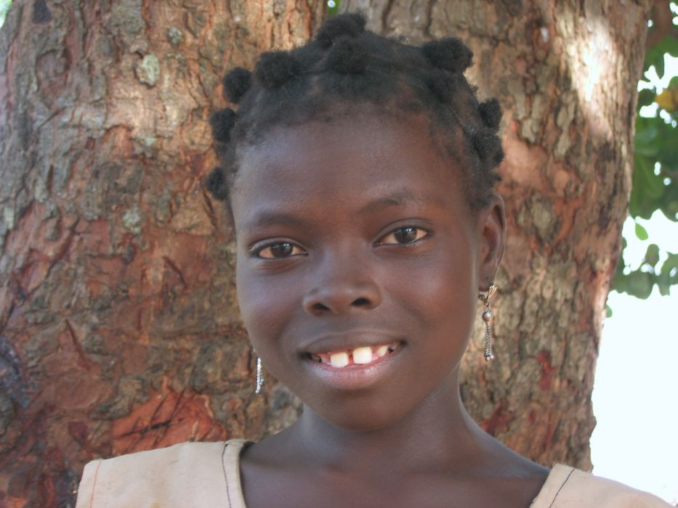  Nanavi  Benin |  | Important information about Benin:  _____________________________________________  _____________________________________________  _____________________________________________  _____________________________________________  _____________________________________________  _____________________________________________  _____________________________________________  _____________________________________________  _____________________________________________
Factor | Negative Impact |  | Positive Impact

Additional information about Nanavi: _____________________________________________
____________________________________________________________________________________________________________________________________________________________________________________________________________________________________________________________________________________________________________________________________________________________________________________________________________________________________________________________________________________
______________________________________________________________________________
______________________________________________________________________________

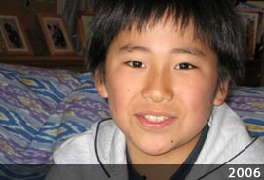  Ken  Japan |  | Important information about Japan:  _____________________________________________  _____________________________________________  _____________________________________________  _____________________________________________  _____________________________________________  _____________________________________________  _____________________________________________  _____________________________________________
Factor | Negative Impact |  | Positive Impact

Additional information about Ken: ________________________________________________
____________________________________________________________________________________________________________________________________________________________________________________________________________________________________________________________________________________________________________________________________________________________________________________________________________________________________________________________________________________
______________________________________________________________________________
______________________________________________________________________________
______________________________________________________________________________
______________________________________________________________________________
______________________________________________________________________________

