AFRICAN MASK
PROJECT
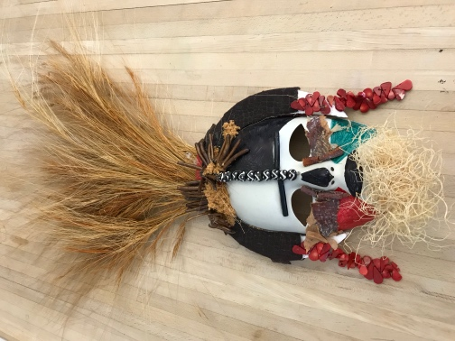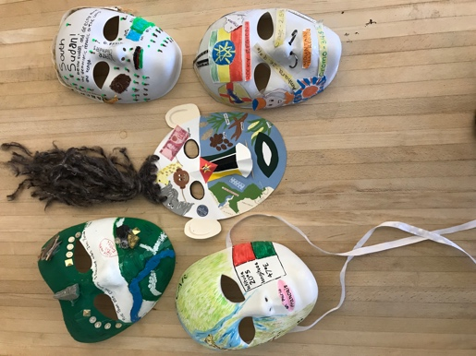
WHY MASKS ARE IMPORTANT:
Masks are an important art form in African countries. When Africans put on masks, they become the force or spirit they are trying to please. Usually, masks are worn by dancers at important celebrations, such as ceremonies for the dead, initiations into society, preparations for war, and rituals to either ward off evil spirits or appeal to good spirits. The powers of the masks increase when they bob and sway with the dancers who wear them.
INSTRUCTIONS CHECKLIST:

- CHOOSE a country from the following regions of Africa:
Northern, East, Central, West, and Southern. ⭙
- RESEARCH Gather facts that relate to each of the 5 themes of Geography in addition to cultural facts. Use your textbook and complete country information form. ⭙
- CONSTRUCT Use your research for inspiration and gather crafty materials in addition to a base (cardboard, paper plate, white mask from party or craft store, etc.). Build your mask! Clean up after yourself and others. ⭙
- REVIEW Make sure your mask:
- Includes your name on the inside and information only on the outside ⭙
- Reflects country’s culture and includes all 5 themes ⭙
- Showcases thoughtfulness, creativity, and effort. ⭙
- SUBMIT Make sure to submit your completed form and mask for evaluation. ⭙
💪WORK HARD AND HAVE FUN! 😁

Name: ______________________________________ Period: ____ Date: ___/___/______
AFRICAN COUNTRY INFORMATION FORM
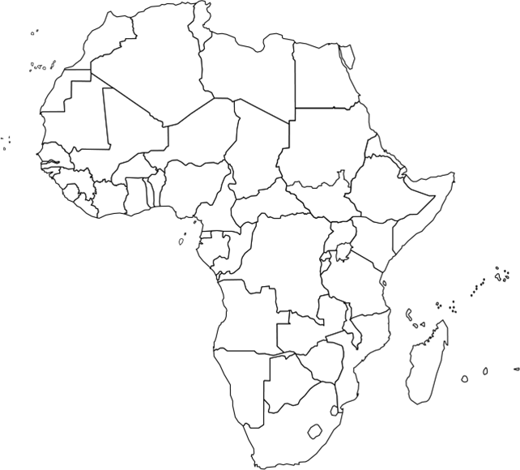

REGION: ____________________________________________________

COUNTRY: __________________________________________________

CAPITAL: ___________________________________________________

LOCATION FACT:
__________________________________________________________________________________________________________________________________________________________________________________________________________________

PLACE FACT:
__________________________________________________________________________________________________________________________________________________________________________________________________________________

HUMAN AND ENVIRONMENTAL INTERACTION FACT:
__________________________________________________________________________________________________________________________________________________________________________________________________________________

MOVEMENT FACT:
__________________________________________________________________________________________________________________________________________________________________________________________________________________

REGION FACT:
__________________________________________________________________________________________________________________________________________________________________________________________________________________

CULTURAL FACT:
__________________________________________________________________________________________________________________________________________________________________________________________________________________
ADDITIONAL FACTS:

THEME: ______________________________________________________________________________________________
_________________________________________________________________________________________________________

THEME: ______________________________________________________________________________________________
_________________________________________________________________________________________________________

THEME: ______________________________________________________________________________________________
_________________________________________________________________________________________________________

THEME: ______________________________________________________________________________________________
_________________________________________________________________________________________________________

THEME: ______________________________________________________________________________________________
_________________________________________________________________________________________________________

THEME: ______________________________________________________________________________________________
_________________________________________________________________________________________________________

THEME: ______________________________________________________________________________________________
_________________________________________________________________________________________________________

THEME: ______________________________________________________________________________________________
_________________________________________________________________________________________________________

THEME: ______________________________________________________________________________________________
_________________________________________________________________________________________________________

THEME: ______________________________________________________________________________________________
_________________________________________________________________________________________________________

